Table of contents

1.0. Animals and enemies 2

2.0. Ghost types 3

3.0. Biomes 3

4.0. Vehicles 4

5.0. Dungeons 4

The game delivered for this bachelor project is only a demo of a potential longer game. So, the game design document represents what is relevant for the final goal of this project, the demo. But we saw value in having ideas for the larger game, as it could help us unify the direction of development. This document details our thoughts on possibilities for the full game.

# 1.0. Animals and enemies

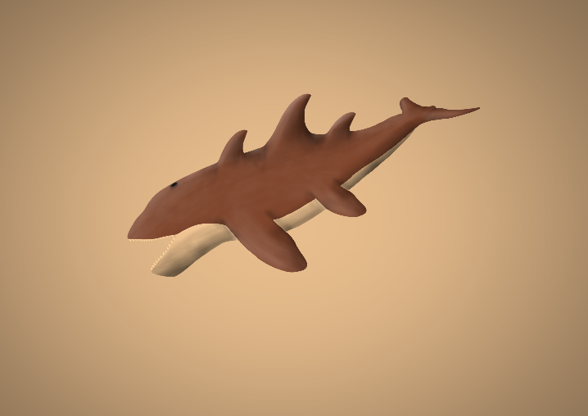One of the earliest additions to the continuation of our game would be to add wildlife to make the world more dynamic. This would give the opportunity to add several features and mechanics that would go well with the current ones. Perhaps most notably, it would open up for combat to give the player more challenges to survive and overcome. Given the whimsical, alien nature of the game, these enemies could be designed with unique dangers and behavior patterns to widen the range of challenges the player would have to learn to overcome. For example, early in the process we developed an idea and concept art for a sand shark, that would swim in the sand. This would mean the player would either have to climb rocks or build platforms to avoid it or they could find ways to fight it directly. This game would work well with a variety of weapons, such as sword, spear or bow and arrow to give the player options of fighting styles. However, it would probably be best fit for a simple combat system with not too many elements and mechanics within, so it doesn’t take too much focus away from other aspects of the game.

Another possibility would be to add friendly animals that give resources, broadening the player’s experience and adding more challenges they need to learn how to overcome. Such animals could take the form of quick runners that must be chased to catch the resource they give. It could also be tame animals the player must capture in personally built enclosures to farm. Or it could be birds that fly across the sky, that the player must find ways to sneak up on or hit down.

# 2.0. Ghost types

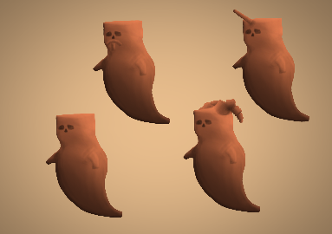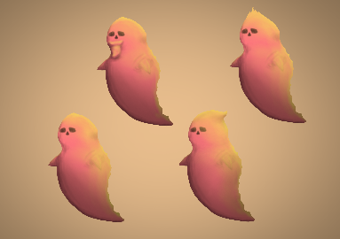Another obvious addition would be to add multiple ghost types. Since machines need to be powered by ghosts, we could separate them based on what they do and make the player chase different ghosts in separate areas. A water ghost connected to a heat regulator could cool the player in the burning sun, while a fire ghost connected to the same machine could heat them during the cold night. An earth ghost could be connected to a resource converter to turn one metal into another. This could add to the possibilities and depth of machines, while also adding to the challenge of finding or fighting ghosts. And some types would probably be more aggressive than others.

# 3.0. Biomes

The full game would need a larger world for the player to explore. This would include multiple biomes tied together through an open world that lets the player explore freely, limited only by their ability to survive. There would need to be at least one biome for each key.

Some possible biomes:

* Red dunes. In this biome, the sand and sky are tinted red to reflect the scorching heat of both the day and night. Here, the player would need to upgrade their survivability and find ways to combat the intense heat.
* Ash dunes. This dark biome is almost devoid of color and teeming with enemies. Here, the player must master the art of combat and find ways to get around the dangerous wildlife.
* Floral biome. This biome is filled with beautiful plant life and lots of animals. It has a large tree in the middle. To enter the tree, the player must solve the puzzles of its roots by crafting the correct items, but be careful not to evoke its wrath by feeding it the wrong solution.
* Lonely mountain. A lonely mountain towers in the far distance, hard to get to because of how far away it is. This could be a smaller biome with not much content, but the challenge comes in upgrading the yourself to be able to get there, and it could contain a crucial further upgrade.
* Water biome. This biome could contain many ponds and a connection of underwater tunnels filled with specific resources. But perhaps there is also something dangerous lurking in the depths.

# 4.0. Vehicles

As the game grows bigger and the distances go farther, vehicles might be a nice addition. This would be a major upgrade that rewards the player by letting them roam much more freely. Multiple types of vehicles could be added. A car could act as a small mobile base with very limited storage space, but with protection from heat. A larger vehicle could act as a more sufficient mobile base but be limited by where it fits. A motorcycle or hoverbike could allow for very quick travel, but without protection from the temperature. A way we could balance these vehicles is through their need for fuel. The player needs to return to a stationary base where they have a machine that makes fuel.

# 5.0. Dungeons

Another thing that could be done is to add more interesting dungeons. Perhaps with some puzzles that need to be solved, or enemies that need to be bypassed (although we’re not entirely sure how well puzzles would fit into the game). These dungeons would probably be most notable at the end of a biome, where the player acquires a key. This could solidify the experience and add more structure to the playthrough.